Lab Report: Network Sniffing and Connectivity Diagnosis
Name: Talha Ali
Environment: Kali Linux (Attacker/Diagnostic) & Metasploitable 2 (Target)

1. Environment Setup & Connectivity
The lab environment was configured using a Host-Only network adapter to ensure a controlled testing environment.
- Kali Linux IP: 192.168.1.4
- Metasploitable 2 IP: 192.168.1.5
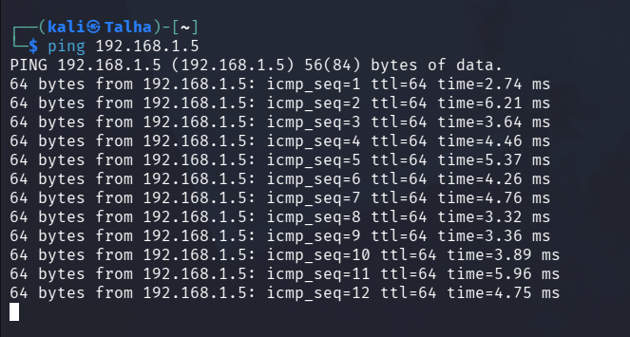
2. Traffic Capture (Wireshark GUI)
Wireshark was initiated on the primary interface (eth0) to monitor real-time packet exchange.
Methodology:
- Started capture via the Wireshark GUI.
- Generated ICMP traffic via terminal.
- Accessed the Metasploitable web server via the Firefox browser.
- Stopped capture after reaching a sufficient sample size (approx. 2 minutes).
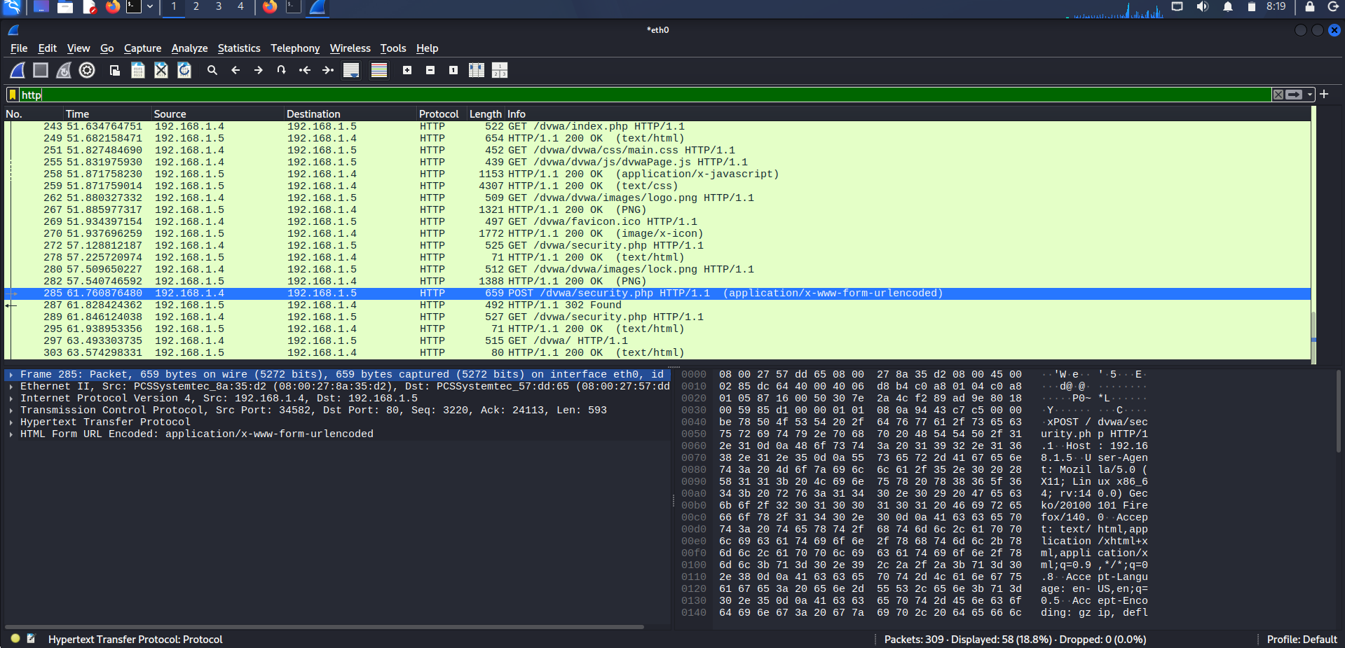
3. Traffic Analysis & Filtering
To diagnose the network health and security posture, specific filters were applied to the capture file.
Applied Filters:
- icmp: Verified reachability and latency.
- http: Inspected web traffic for unencrypted data.
- tcp.flags.reset == 1: Searched for rejected connection attempts.
TCP Stream Follow:
By selecting a packet and using Follow > TCP Stream, the full application-layer conversation was reconstructed.

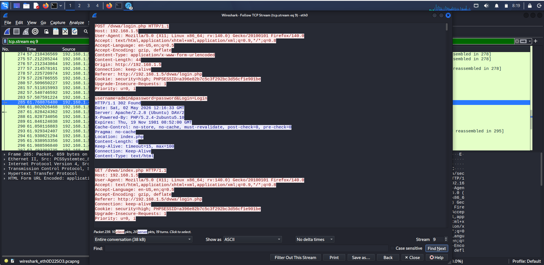
4. Command Line Capture (tcpdump)
For lightweight or remote analysis, tcpdump was utilized to capture packets directly to a .pcap file.
Executed Command:
sudo tcpdump -i eth0 -w capture.pcap host [Target_IP]
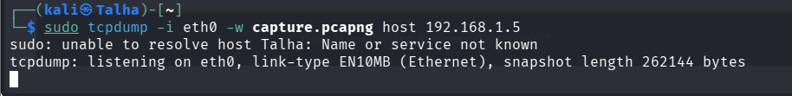
5. Diagnosis & Security Findings
Security Assessment
- Sensitive Data Exposure: Critical. Plaintext credentials were successfully intercepted during a login attempt to the /dvwa/login.php page. The packet analysis revealed the following sensitive information in an unencrypted POST body:
  - Username: admin
  - Password: password
  - Session ID: a396e82b7c5c3f292bc3d56cf1e901be (found in the PHPSESSID cookie). Since the traffic is not encrypted, any user on the same network could perform a session hijack or credential theft.
- Connectivity Health: The connectivity between the attacker (Kali) and the target (Metasploitable) is stable. The HTTP/1.1 200 OK responses and the subsequent successful loading of the index.php page indicate that there is no significant packet loss, firewall interference, or TCP reset (RST) activity on the observed ports.
Root Cause Analysis
The primary security vulnerability identified is the use of the unencrypted HTTP protocol (Port 80) for transmitting authentication data.
Because HTTP lacks Transport Layer Security (TLS), data is sent in cleartext. This allows a network sniffer (like Wireshark or tcpdump) to perform a passive Man-in-the-Middle (MitM) attack, reconstructing the entire session and harvesting credentials without the user's knowledge.

6. Recommendations
- Enforce Encryption (HTTPS): Transition the web application from HTTP to HTTPS by installing an SSL/TLS certificate. This ensures that all data between the browser and the server is encrypted, rendering intercepted packets unreadable.
- Secure Cookie Attributes: Implement the Secure and HttpOnly flags on the PHPSESSID cookie. The Secure flag ensures the cookie is only sent over encrypted connections, while HttpOnly prevents client-side scripts from accessing it.
- Disable Legacy Protocols: Identify and disable other plaintext management protocols on the host, such as Telnet (Port 23) and FTP (Port 21), replacing them with SSH and SFTP.
- Network Hardening: Implement Dynamic ARP Inspection (DAI) and DHCP Snooping on the network switches to prevent attackers from using ARP poisoning to redirect traffic into their sniffing tools.

